Test Case: tc001_SPX_Dev5_Crear_Requisicion_Spot_Tipo_Cobro_CC
Step 1 - Enter username and password and click to button Enter : Credentials Entered
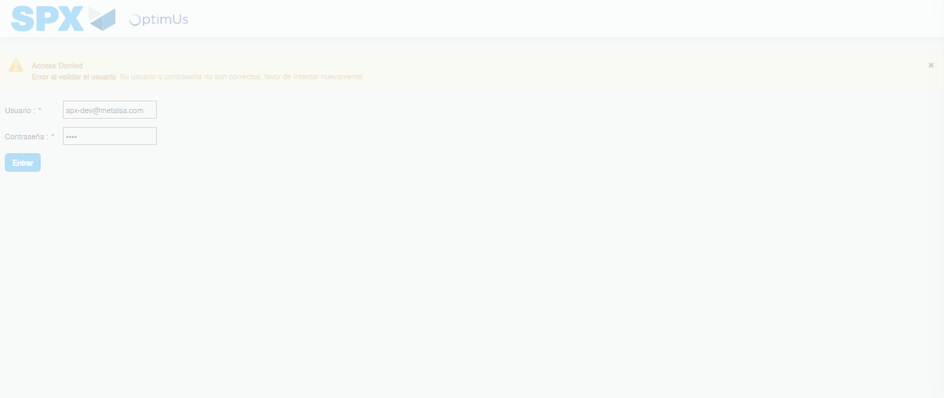Image file-name: QC_Testing-tc001_SPX_Dev5_Crear_Requisicion_Spot_Tipo_Cobro_CC-1783984079496

Step 2 - Select to UEN and Access to Spot Buy Requisitions : UEN Correctly selected and Correct access
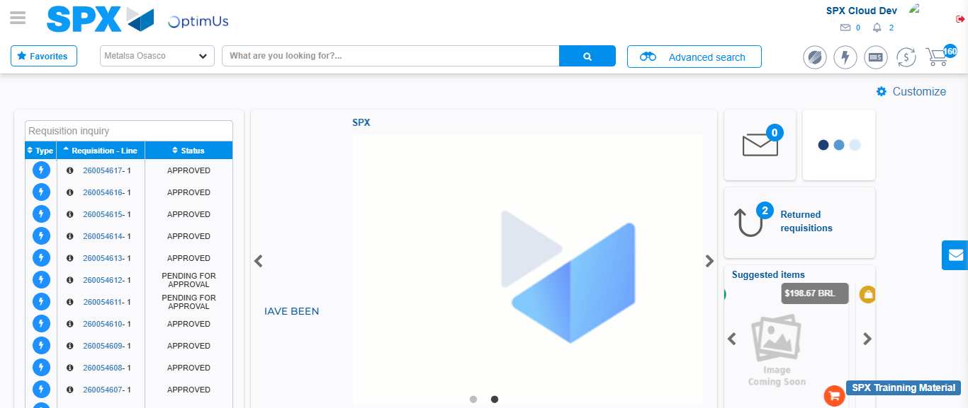Image file-name: QC_Testing-tc001_SPX_Dev5_Crear_Requisicion_Spot_Tipo_Cobro_CC-1783984105875

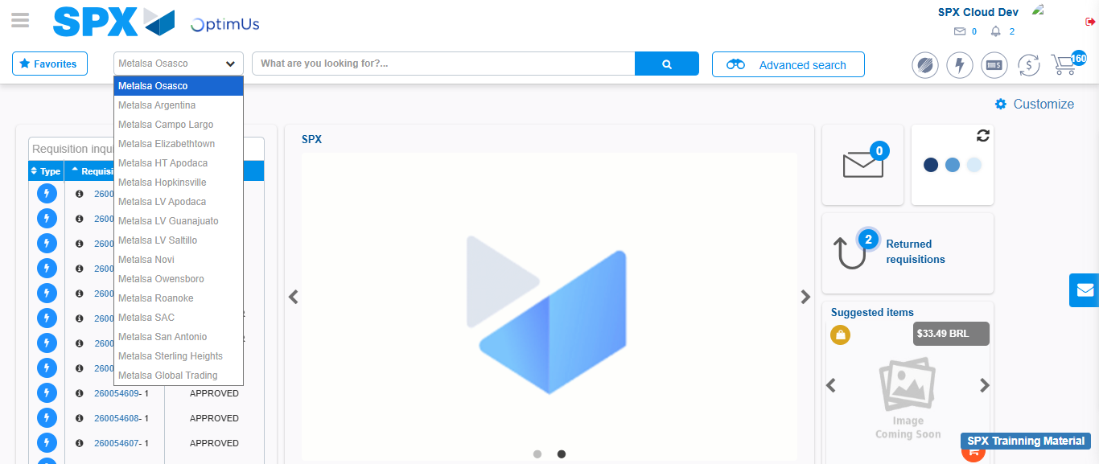Image file-name: QC_Testing-tc001_SPX_Dev5_Crear_Requisicion_Spot_Tipo_Cobro_CC-1783984108466

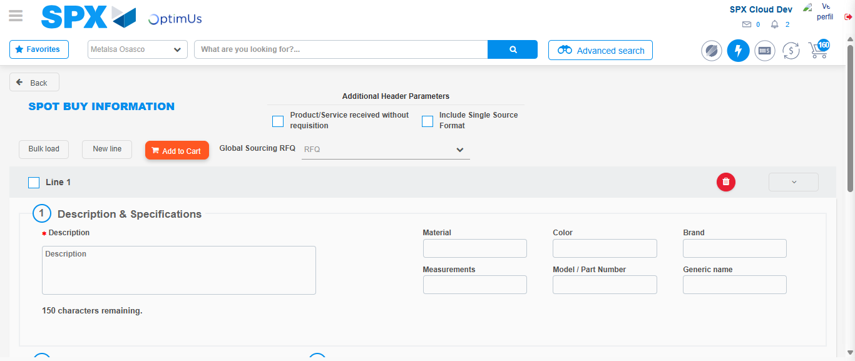Image file-name: QC_Testing-tc001_SPX_Dev5_Crear_Requisicion_Spot_Tipo_Cobro_CC-1783984129203

Step 3 - Data Capture Spot Buy Requisition : Data captured correctly
Image file-name: QC_Testing-tc001_SPX_Dev5_Crear_Requisicion_Spot_Tipo_Cobro_CC-1783984129412

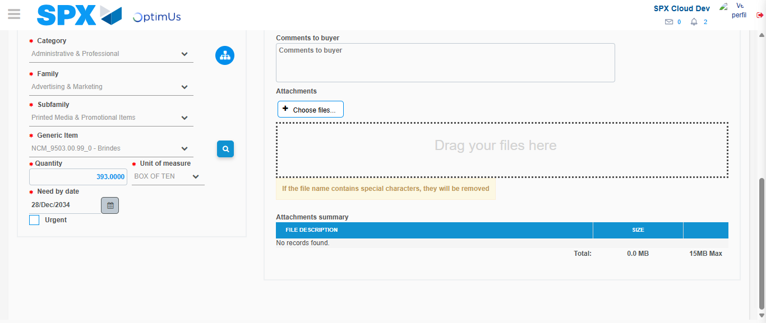Image file-name: QC_Testing-tc001_SPX_Dev5_Crear_Requisicion_Spot_Tipo_Cobro_CC-1783984140566

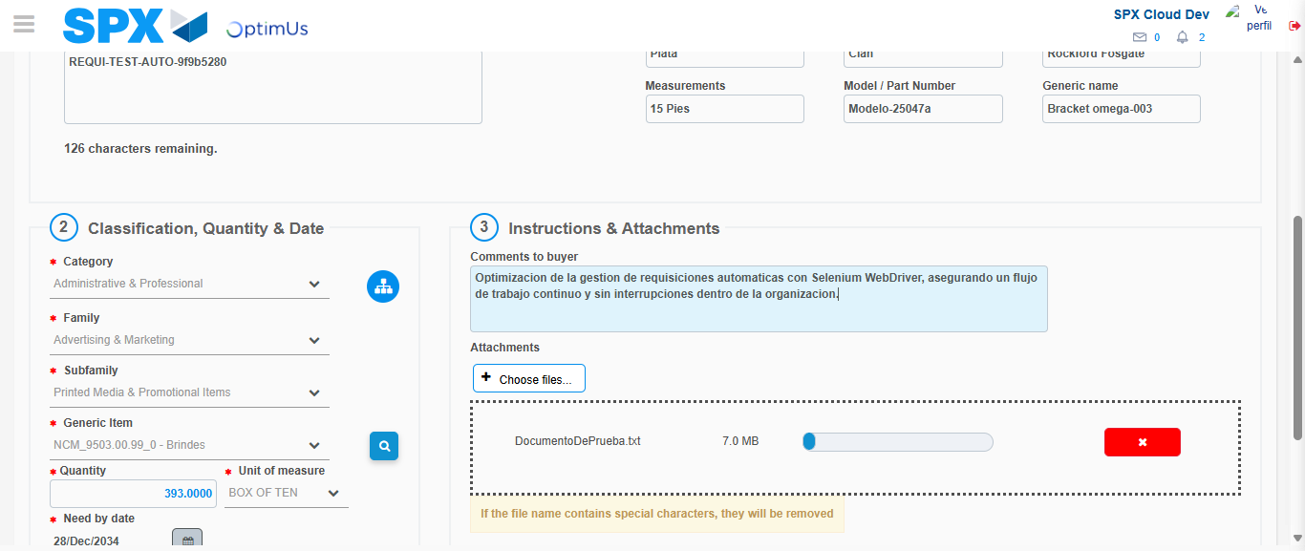Image file-name: QC_Testing-tc001_SPX_Dev5_Crear_Requisicion_Spot_Tipo_Cobro_CC-1783984141316

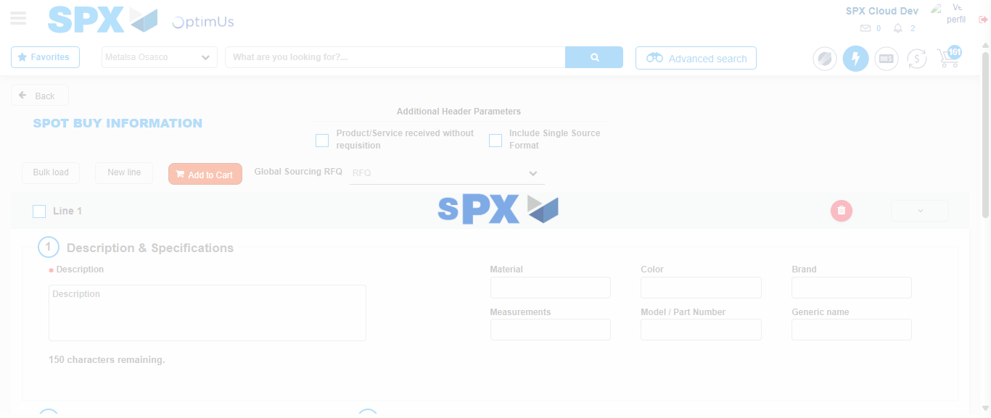Image file-name: QC_Testing-tc001_SPX_Dev5_Crear_Requisicion_Spot_Tipo_Cobro_CC-1783984151862

Step 7 - Return to Main Page SPX : Return to Main Page SPX
Image file-name: QC_Testing-tc001_SPX_Dev5_Crear_Requisicion_Spot_Tipo_Cobro_CC-1783984105875

Image file-name: QC_Testing-tc001_SPX_Dev5_Crear_Requisicion_Spot_Tipo_Cobro_CC-1783984108466

Image file-name: QC_Testing-tc001_SPX_Dev5_Crear_Requisicion_Spot_Tipo_Cobro_CC-1783984129203

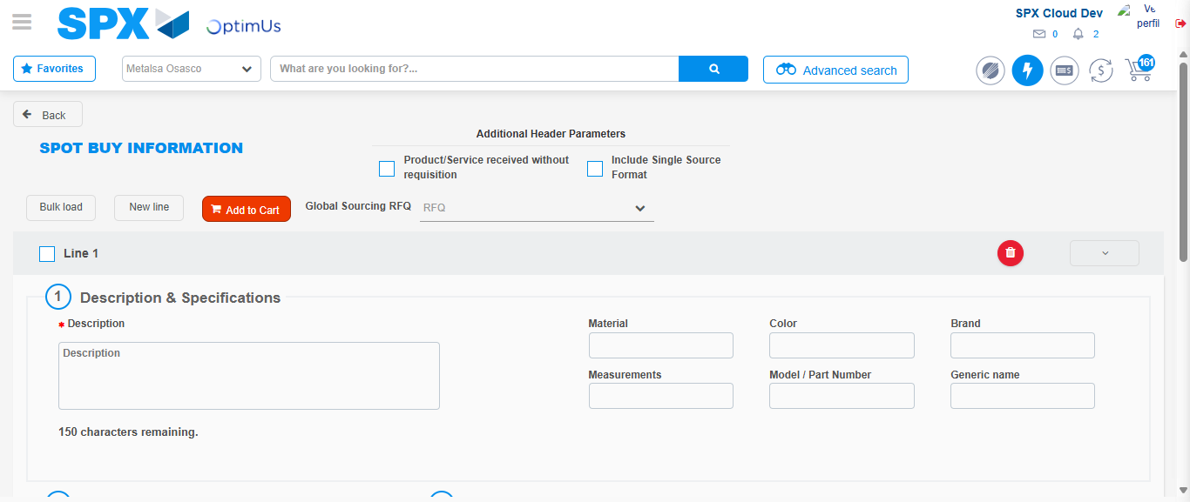Image file-name: QC_Testing-tc001_SPX_Dev5_Crear_Requisicion_Spot_Tipo_Cobro_CC-1783984154056

Image file-name: QC_Testing-tc001_SPX_Dev5_Crear_Requisicion_Spot_Tipo_Cobro_CC-1783984154214

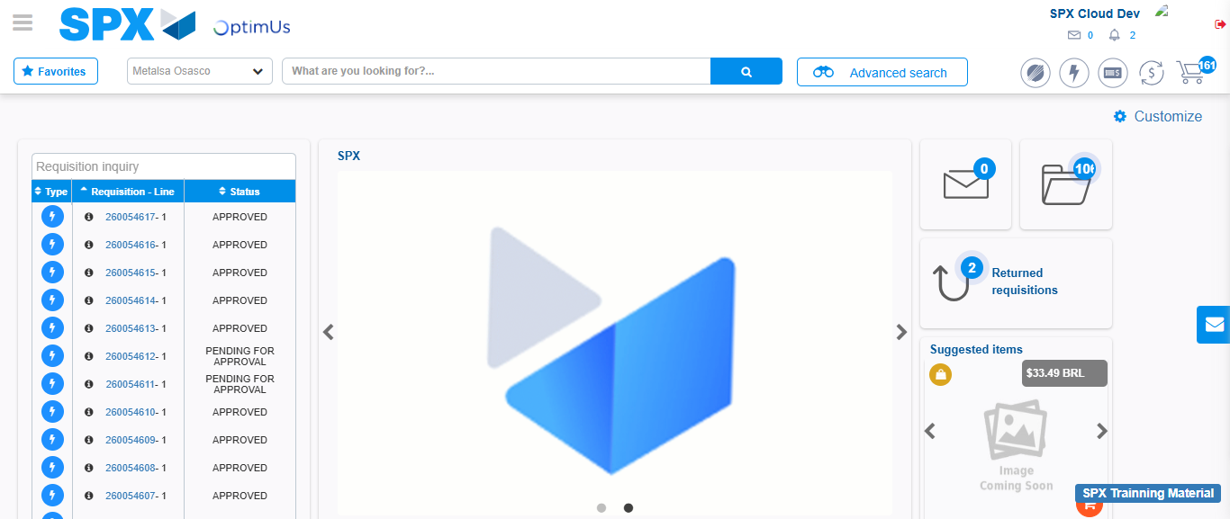Image file-name: QC_Testing-tc001_SPX_Dev5_Crear_Requisicion_Spot_Tipo_Cobro_CC-1783984175231

Step 8 - Log Out : Log Out SPX
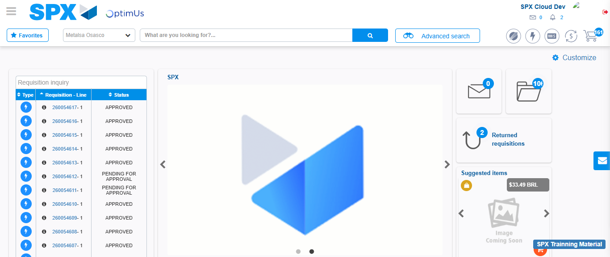Image file-name: QC_Testing-tc001_SPX_Dev5_Crear_Requisicion_Spot_Tipo_Cobro_CC-1783984175517

